N-Queens Problem

Assignment 2

|  |  |
| --- | --- |
| **خالد عبدالعزيز الدويسان** |  |
| **علي بن دهيم** |  |
| **عبدالعزيز العريفي** |  |
| **عبدالرحمن الميمان** |  |

Description :

The aim of this problem is to place N queens on a chessboard of size NxN in an order where no queen may attack another. A queen can attack other queens either diagonally, or in same row or column.

State Representation :

1. ***State:*** NxN grid with N-queens with cost and heuristic function if exist.
2. ***Initial state:*** queens are randomly distributed across the board.
3. ***Actions:*** The user can use any search algorithm to reach Goal state.
4. ***Goal State:*** N-queens are distributed where no queen can attack another.

Description of the Solution implementation :

In this implementation we used 2-Dimensional array With N-queens are randomly generated, and solved with 4 Search algorithms BFS,DFS,Greedy,A* -3 data structures are used:

*BFS DFS Greedy A\**

*Data* Queue Stack Priority Priority

*Structure* queue queue

Sample Run :

Initial State BFS

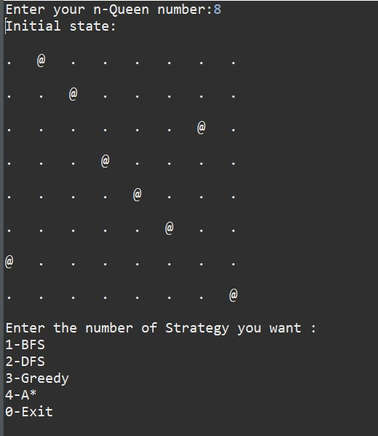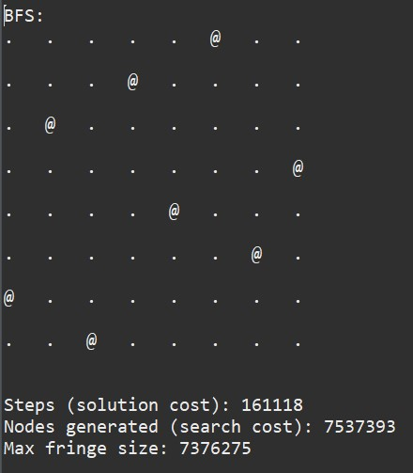

DFS

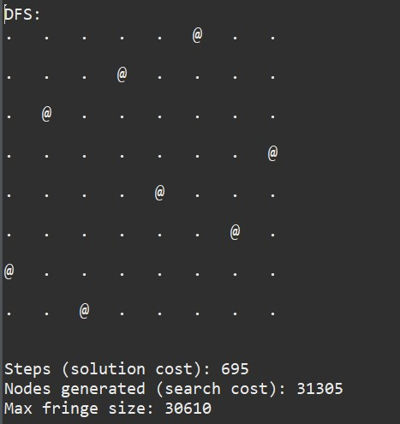

Greedy A*

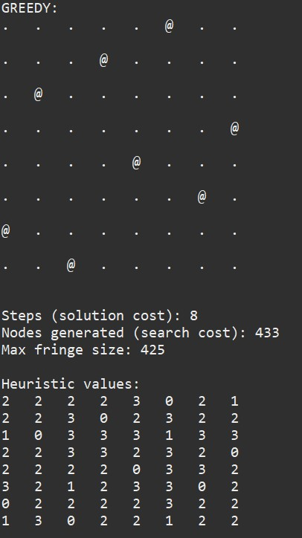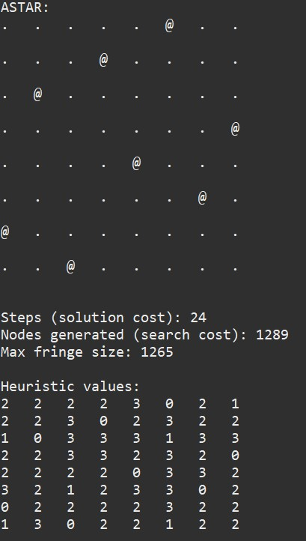

Discussion of the result :

The results are clearly better when using GREEDY search path costs often don’t exceed 10, and worst algorithm is BFS solution cost is the highest also it takes a lot of memory.